|  |
| --- |
| Asia pasific university of technology & innovation |
| Project Report |
| Internet Application |
|  |
| **Muhammad Fayzan Siddiqui**  **Student ID: TP033089**  **Intake code: UCMP1308MCS**  **Lecturer: Naresh Kumar Appadurai** |
| **Date Assigned: 25th January 2014**  **Date Completed: 10th March 2014**  **Screen Shots Of E-Commerce Store Application for Travel & Tours** |



|  |
| --- |
|  |

Following are the screen-shots of the e-commerce application for travels & tours.

1. Main Page of application

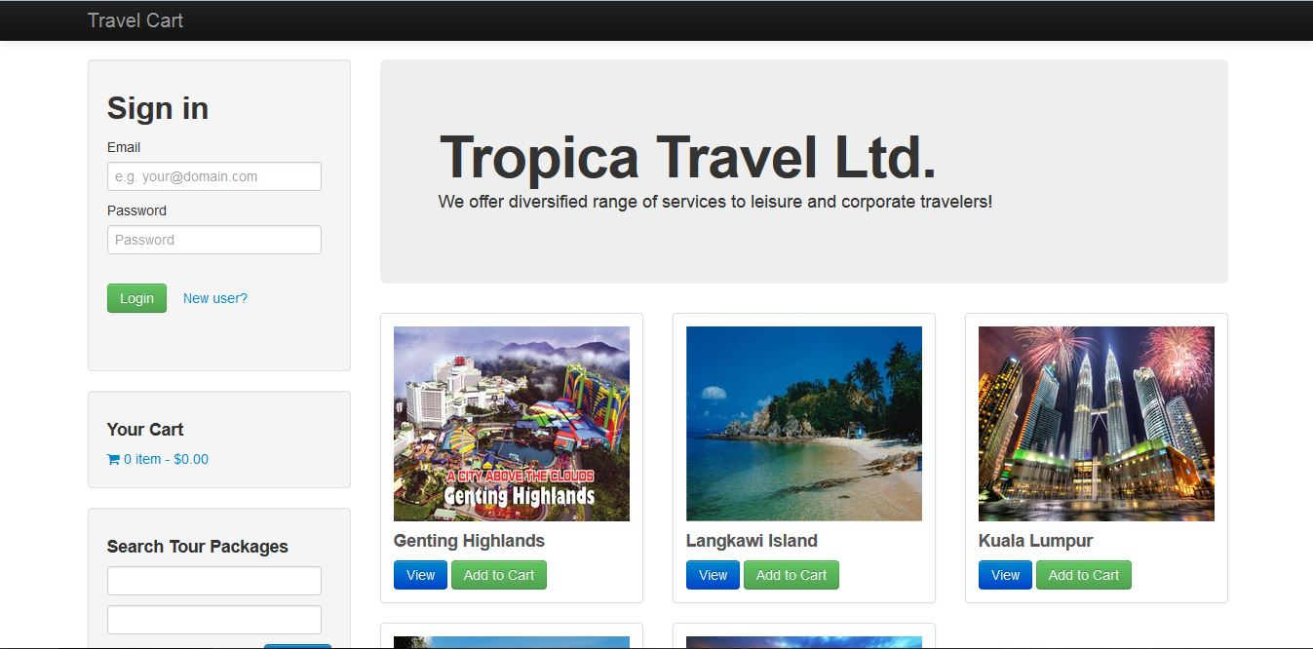

1. Product search

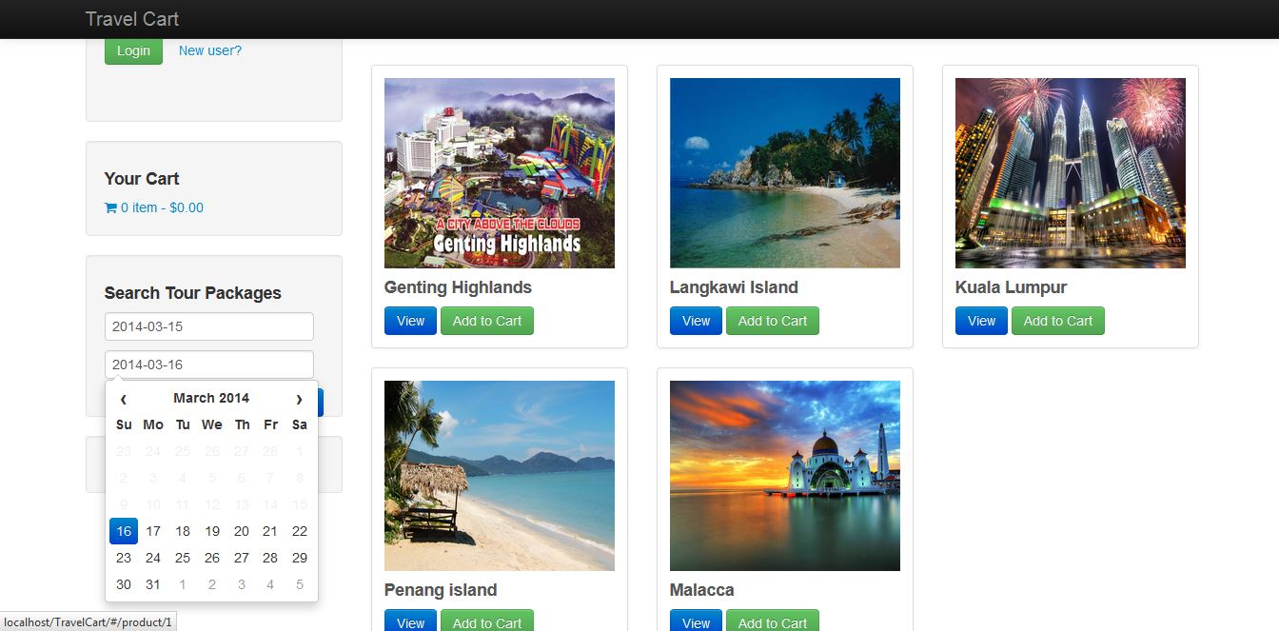

1. Shopping cart

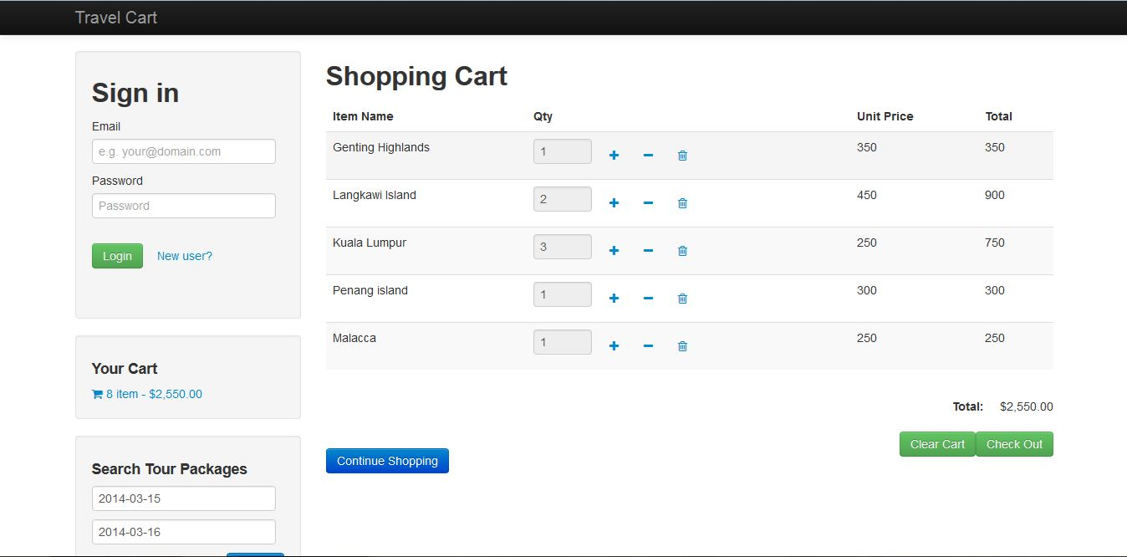

1. Member registration

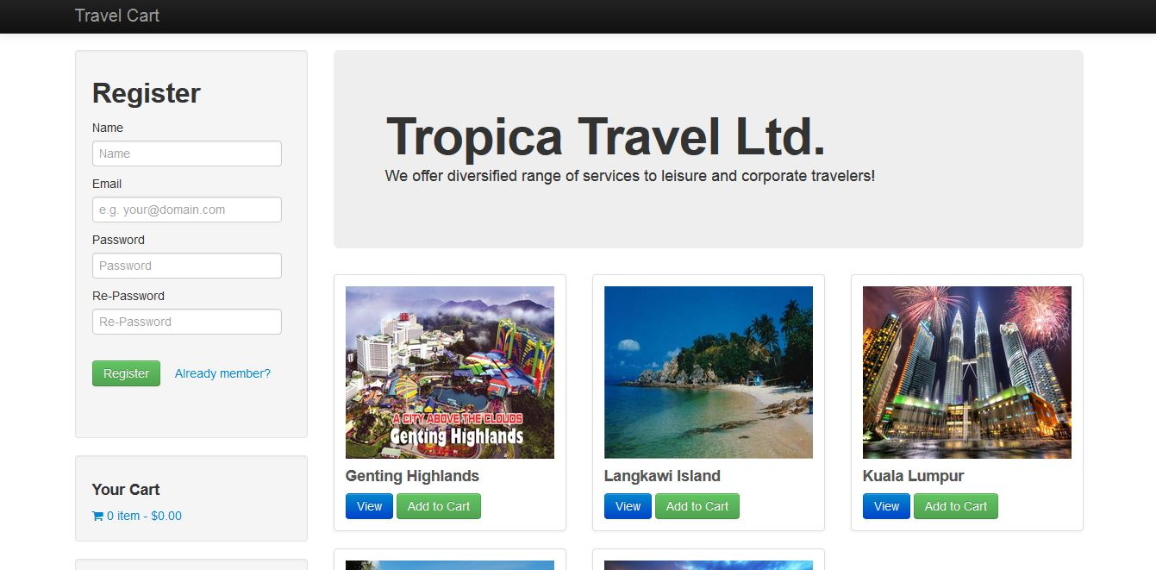

1. Member panel

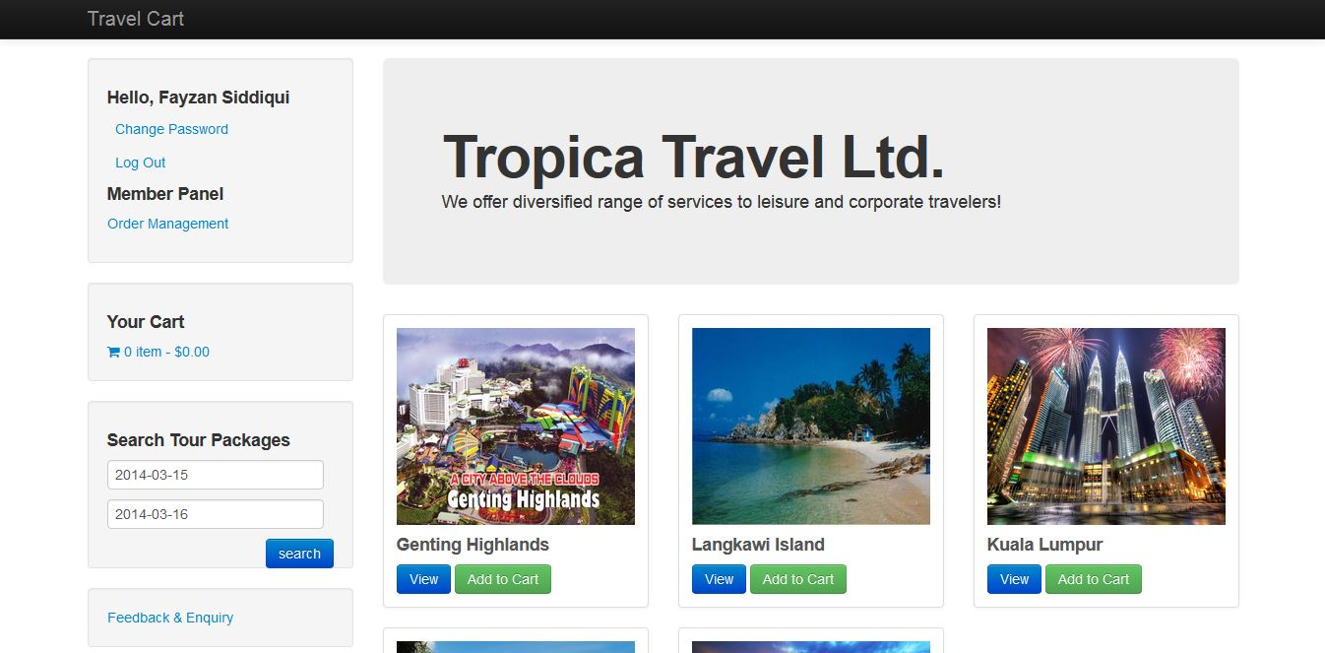

1. PayPal payment

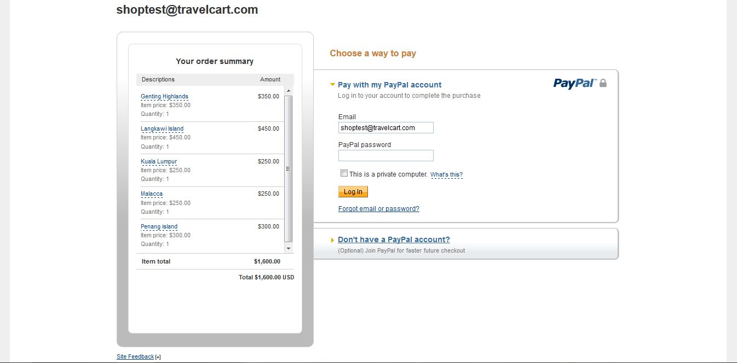

1. Order management by member

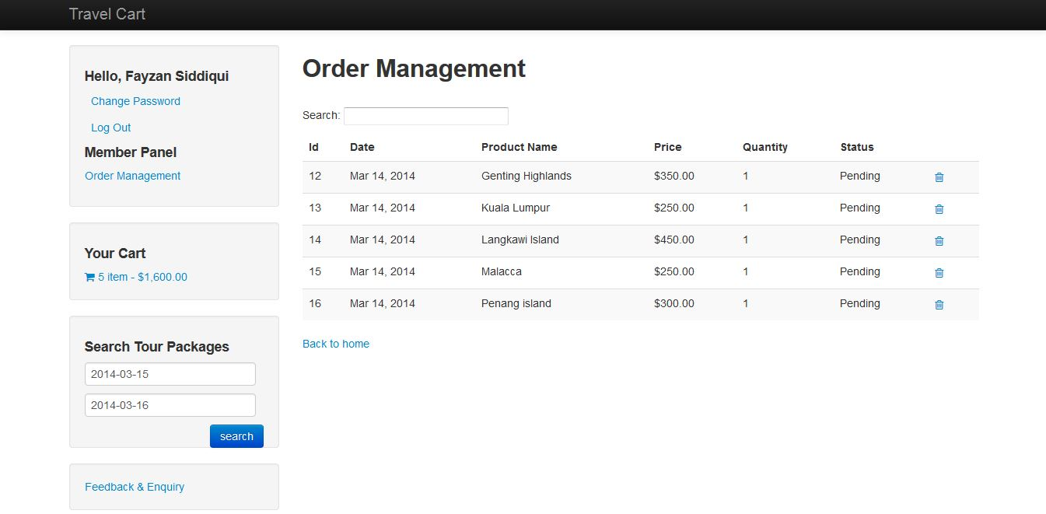

1. Feedback &Enquiries by member

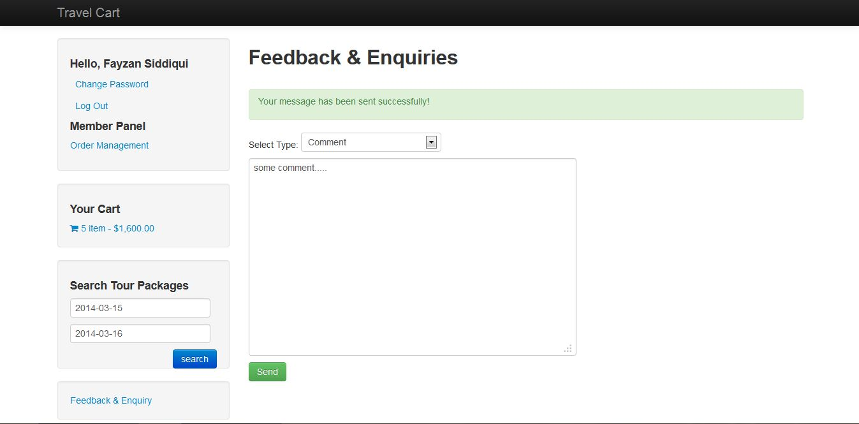

1. Change password

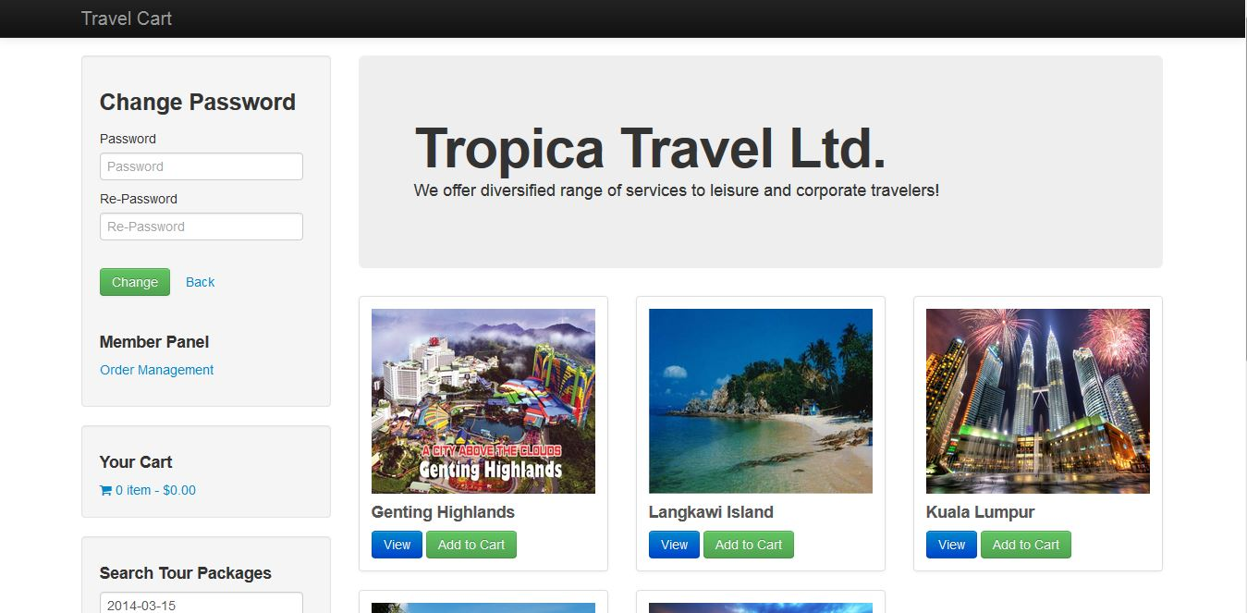

1. Admin panel

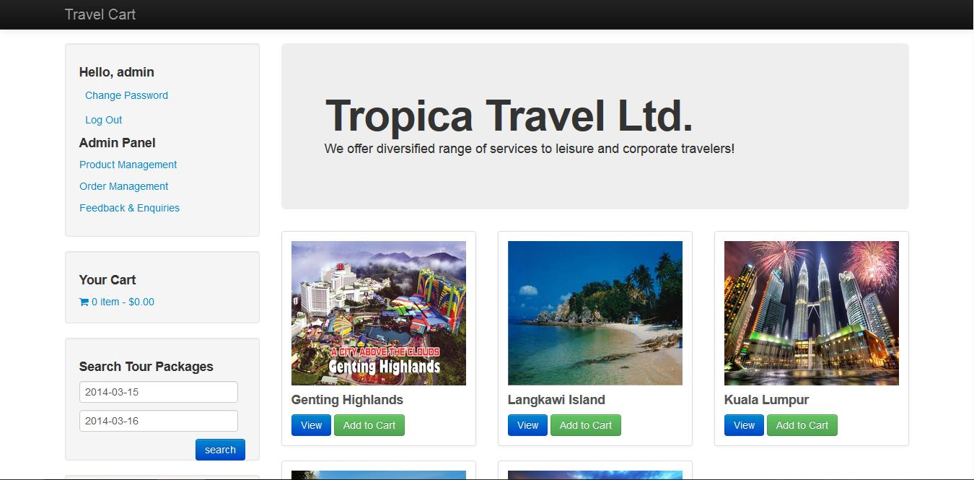

1. Product management

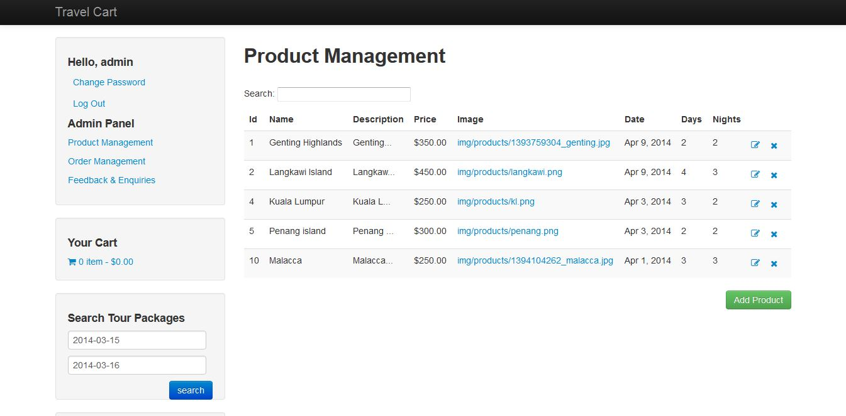

1. Add product

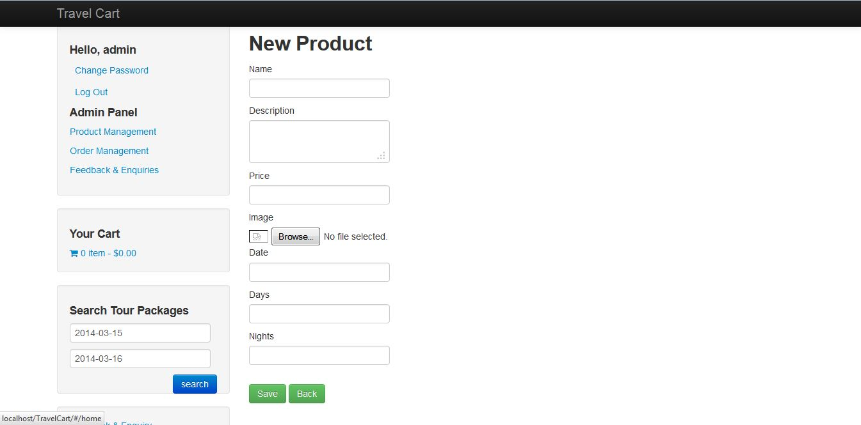

1. Edit product

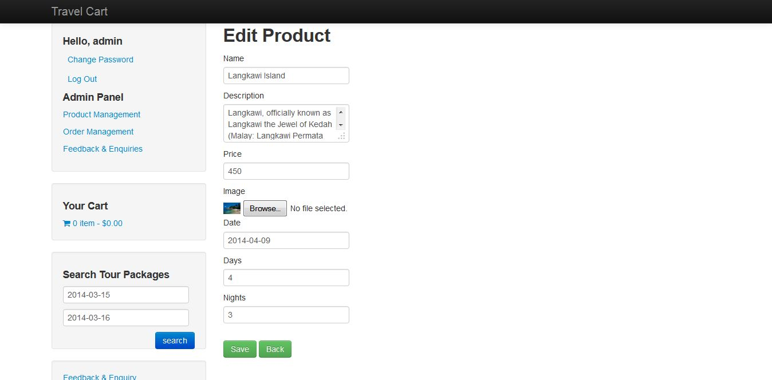

1. Order management by admin

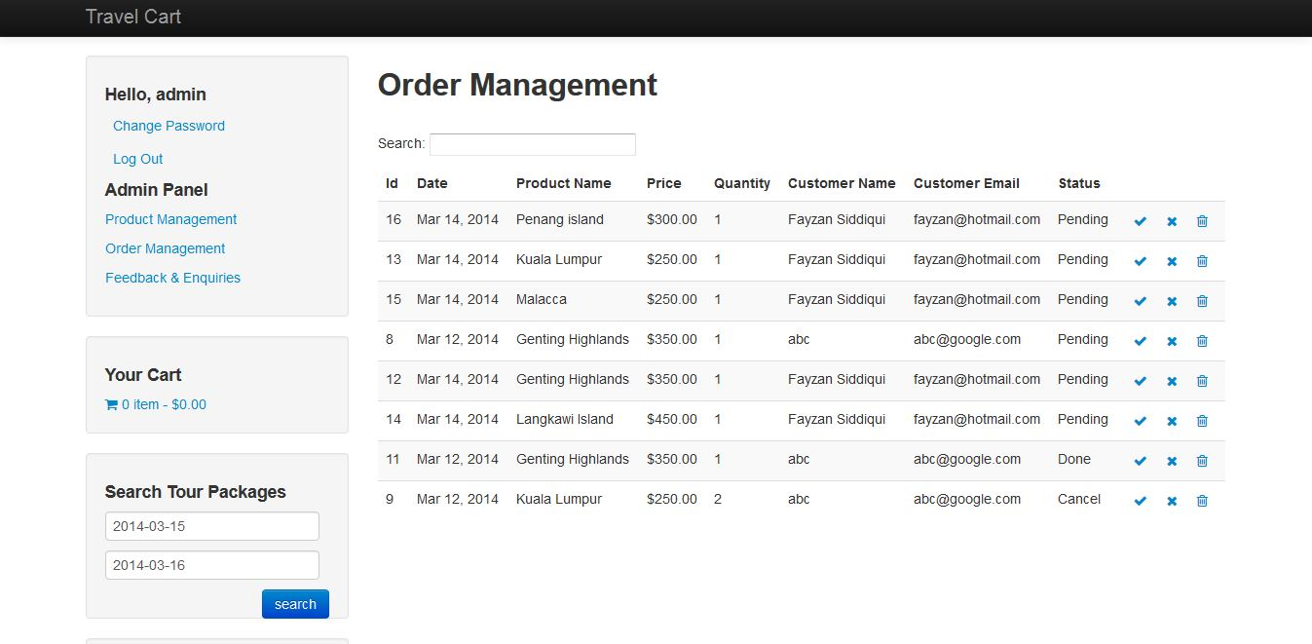

1. Feedback & Enquiries by admin

